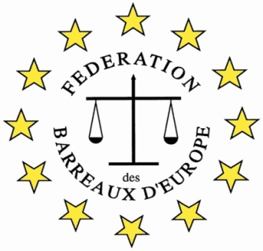

The FBE International Law Firm of the Future Competition 2019

Application Form

The Bar
Participating Bar
Contact Person in the Bar
Phone (international format)
E-mail
The Participant
Participant
Phone
E-mail
Additional Notes

Candidates’ applications should be sent to their Bar Associations and the Bar
should send it to the International Committee at the Bar Association in Wrocław,
to the following e-mail address: dyrektor@oirp.wroclaw.pl by 15 th January 2019.
In case of students the application may be directly submitted online to the Bar Association in Wrocław to the following e-mail address: dyrektor@oirp.wroclaw.pl by 15 th January 2019.

